**CA3001 – Programming and Data Structures using C**

**Assignment 5 - 04.01.2021**

**Q1.** Find the sum of first 10 natural numbers (Using for loop).

Ans -C Program & Output :

#include <stdio.h>

int main()

{

int i, sum = 0;

printf("The first 10 natural numbers are :\n");

for (i = 1; i <= 10; i++)

{

sum = sum + i;

printf("%d ",i);

}

printf("\nThe Sum is : %d\n", sum);

return 0;

}

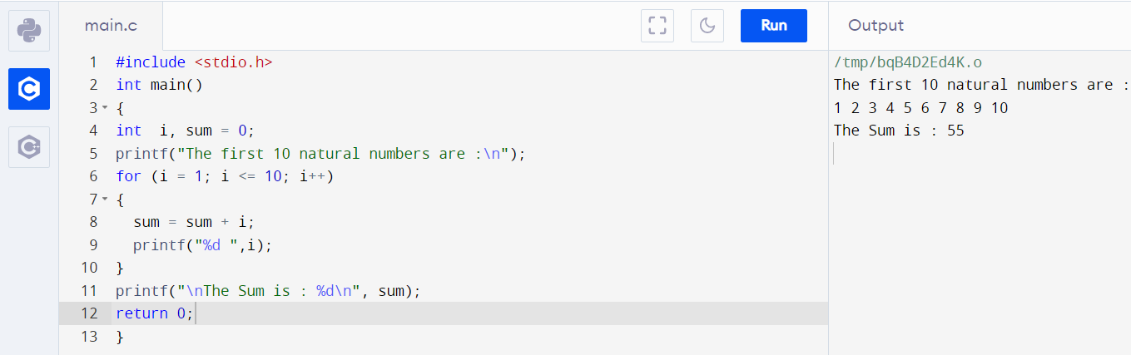

**Q2.** Display the multiplication table of a given integer (Using while loop).

Ans – C Program & Output :

#include <stdio.h>

int main()

{

int n, i;

printf("Enter a Number ");

scanf("%d",&n);

i=1;

while(i<=10)

{

printf("%d * %d = %d \n", n, i, n*i);

++i;

}

return 0;

}

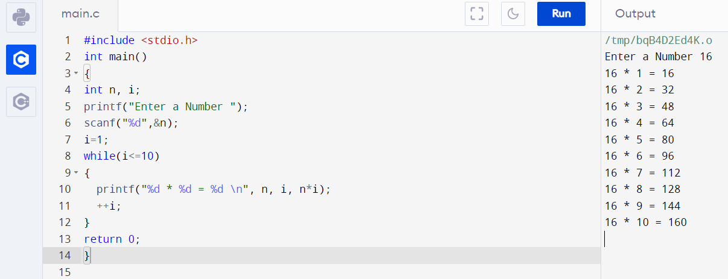

**Q3.** Display the n terms of odd natural number and their sum (Using do...while loop)

Ans – C Program & Output:

#include <stdio.h>

int main()

{

int i=1,n,sum=0,count=0;

printf("enter the value of n:\n");

scanf("%d",&n);

do

{

if(i%2!=0)

{

printf("%d\t",i);

sum += i;

count++;

}

i++;

}

while(count<=n);

printf("\nthe sum of %d odd natural numbers is:%d",n,sum);

return 0;

}

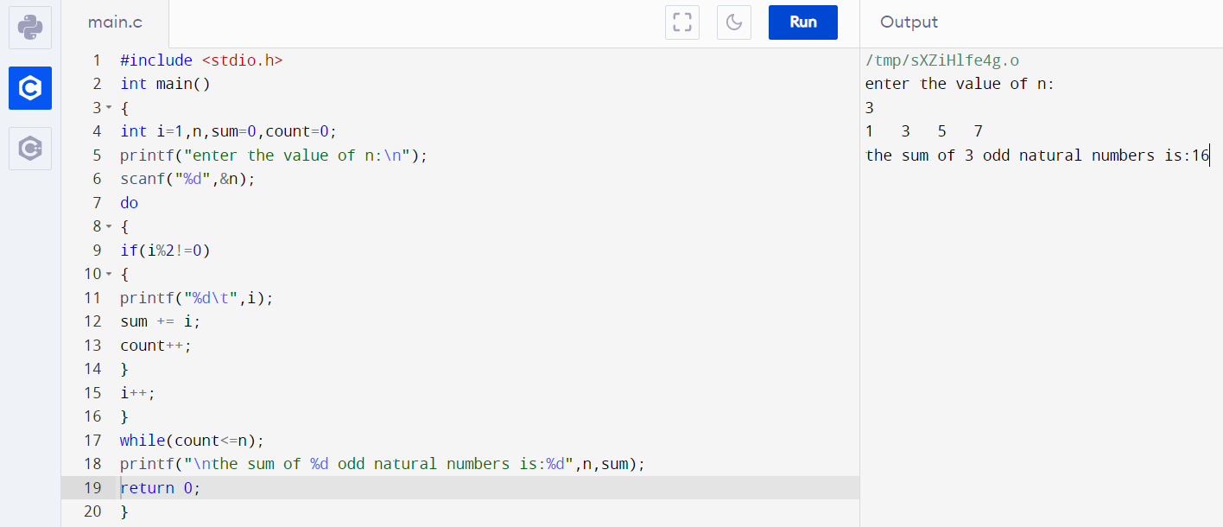

**Q4.** Display the pattern like right angle triangles.

(Using for loop).

*

**

***

****

Ans – C Program & Output:

#include <stdio.h>

int main()

{

int i,j,rows;

printf("Input number of rows : ");

scanf("%d",&rows);

for(i=1;i<=rows;i++)

{

for(j=1;j<=i;j++)

printf("*");

printf("\n");

}

return 0;

}

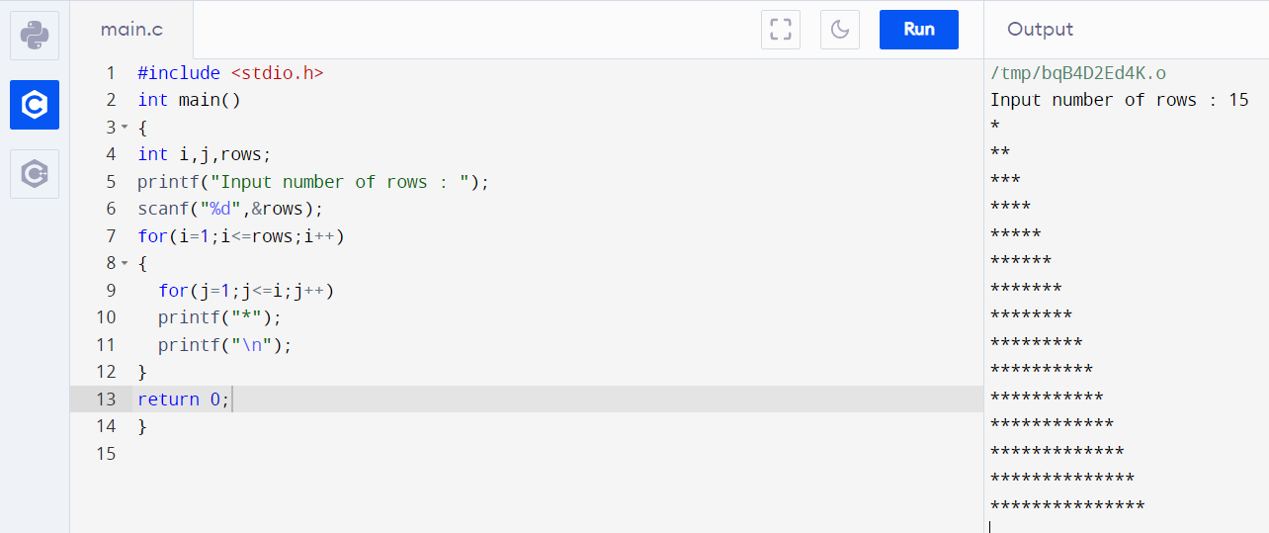

**Q5**. Display the pattern like right angle triangles.

(Using while loop)

1

2 3

4 5 6

7 8 9 10

Ans – C Program & Output:

#include<stdio.h>

int main()

{

int i, j, rows, count = 1;

printf("Enter the number of rows:");

scanf("%d", &rows);

for (i = 0; i < rows; i++)

{

for (j = 0; j <= i; j++)

{

printf("%d ", count);

count++;

}

printf("\n");

}

return(0);

}

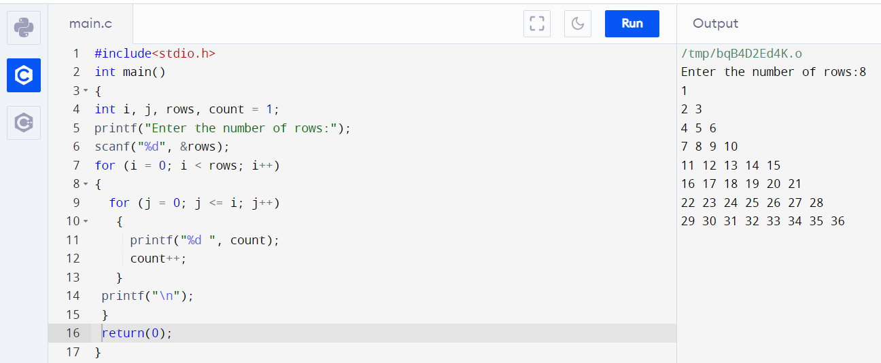

**Q7.** Display Pascal's triangle. (Using for loop)

1

1 1

1 2 1

1 3 3 1

1 4 6 4

Ans – C Program & Output:

#include <stdio.h>

int main()

{

int row,c=1,block,i,j;

printf("Input number of rows: ");

scanf("%d",&row);

for(i=0;i<row;i++)

{

for(block=1;block<=row-i;block++)

printf(" ");

for(j=0;j<=i;j++)

{

if (j==0||i==0)

c=1;

else

c=c*(i-j+1)/j;

printf("% 4d",c);

}

printf("\n");

}

return 0;

}

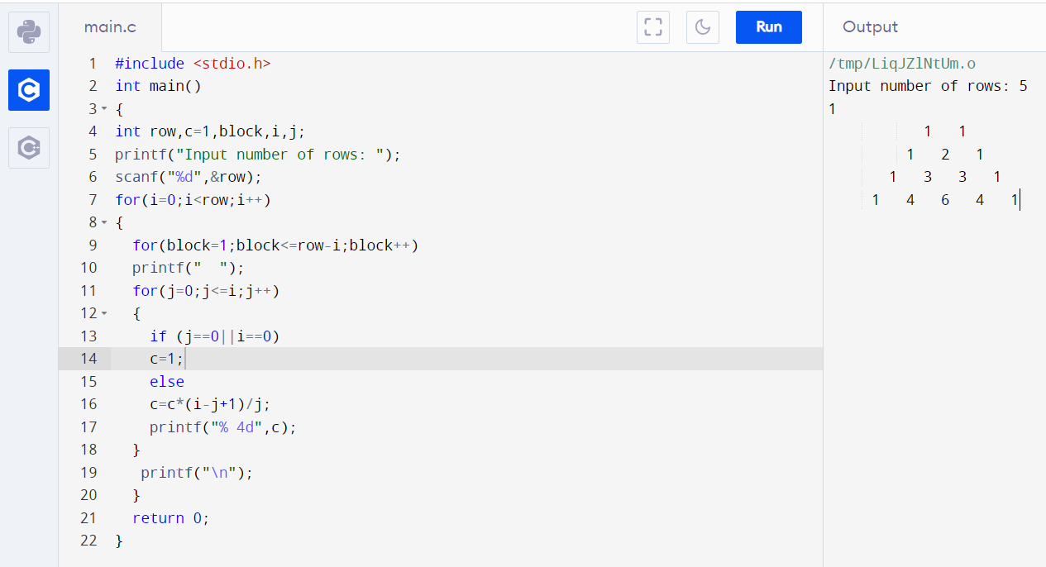

**Q8.** Display the first n terms of Fibonacci series. (Using for loop)

Ans – C Program & Output:

#include<stdio.h>

int main()

{

int n1=0,n2=1,n3,i,number;

printf("Enter the number of elements:");

scanf("%d",&number);

printf("\n%d %d",n1,n2);//printing 0 and 1

for(i=2;i<number;++i)//loop starts from 2 because 0 and 1 are already printed

{

n3=n1+n2;

printf(" %d",n3);

n1=n2;

n2=n3;

}

return 0;}

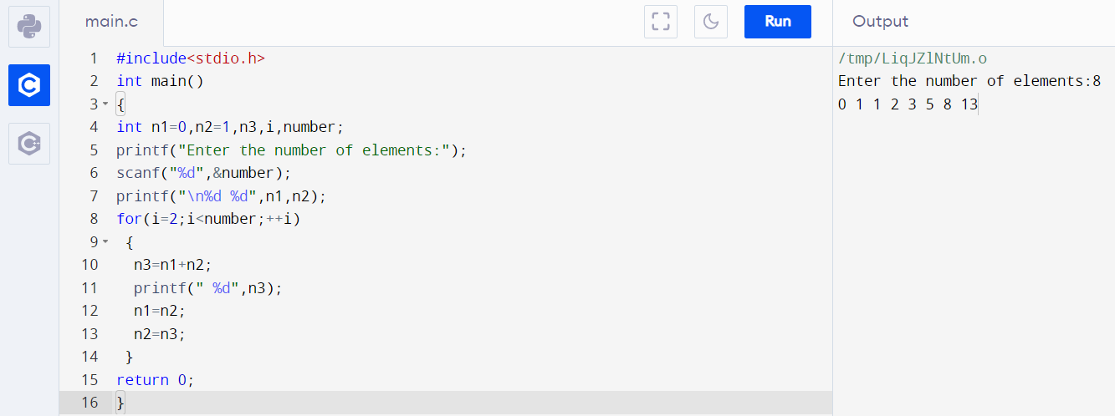

**Q9.** Check whether a given number is a perfect number or not. (Using while loop)

Ans – C Program & Output:

#include<stdio.h>

Int main()

{

int num, count = 1, sum = 0;

printf("Enter a number\n");

scanf("%d", &num);

while(count < num)

{

if(num%count == 0)

{

sum = sum + count;

}

count++;

}

if(sum == num)

{

printf("\n%d is a perfect number\n", num);

}

else

{

printf("\n%d is not a perfect number\n", num);

}

return 0;

}

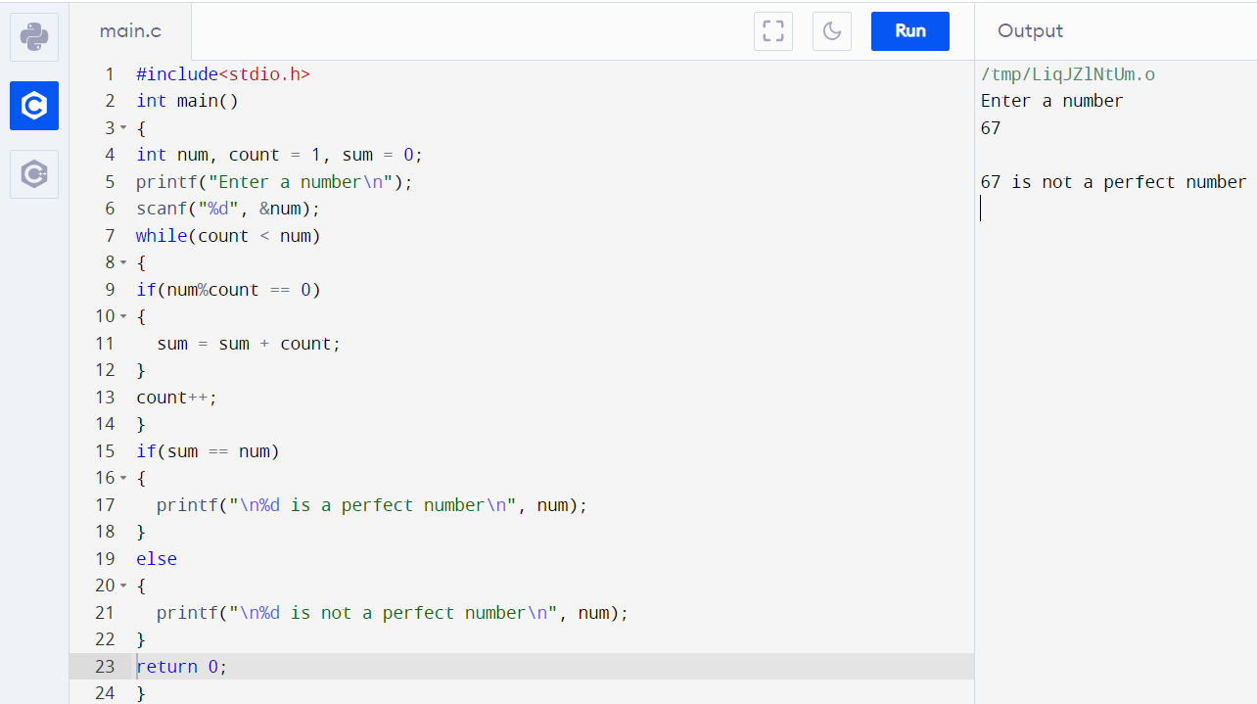

**Q10.** Find the Armstrong number for a given range of number. (Using while loop)

Ans – C Program & Output:

#include<stdio.h>

int main()

{

int num,r,sum,temp;

int stno,enno;

printf("Enter starting range: ");

scanf("%d",&stno);

printf("Enter ending range : ");

scanf("%d",&enno);

printf("Armstrong numbers in given ranges are: ");

for(num=stno;num<=enno;num++)

{

temp=num;

sum = 0;

while(temp!=0)

{

r=temp % 10;

temp=temp/10;

sum=sum+(r*r*r);

}

if(sum==num)

printf("%d ",num);

}

printf("\n");

return 0;

}

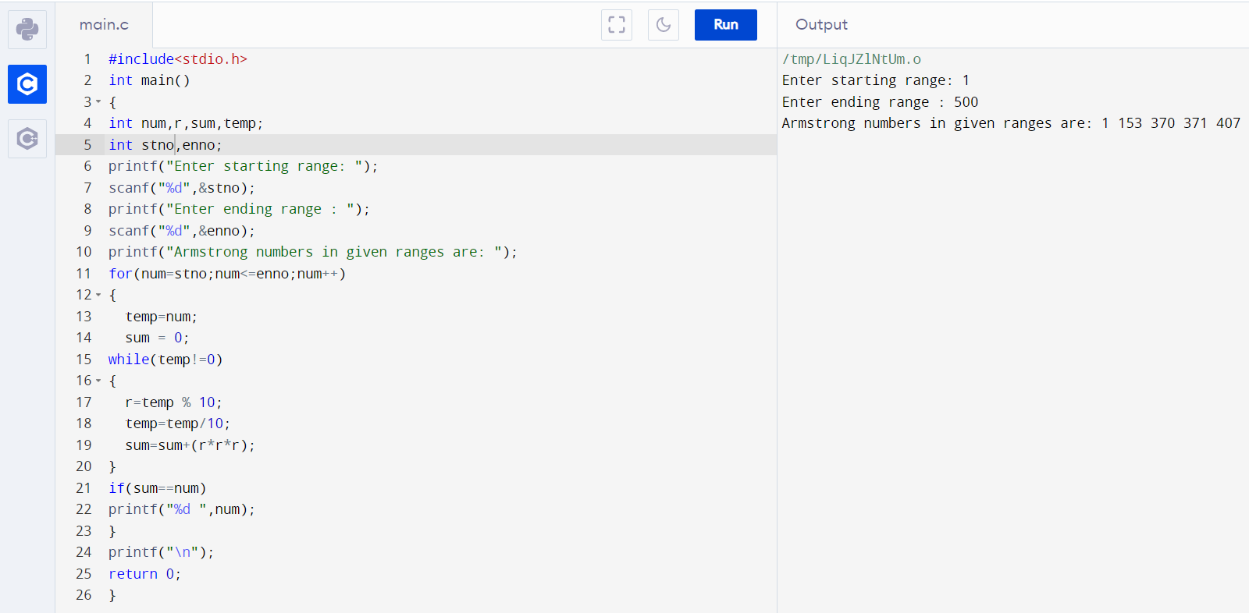

**Q11.** Determine whether a given number is prime or not. (Using do...while loop)

Ans – C Program & Output:

#include <stdio.h

int main()

{

int num,i,count=0;

printf("Enter the positive integer\n");

scanf("%d",&num);

i=2;

do

{

if(num%i==0)

{

count=1;

break;

}

i++;

}

while(i<=num/2);

if(count==0)

{

printf("%d is a prime number ",num);

}

else

{

printf("%d is not a prime number ",num);

}

return 0;

}

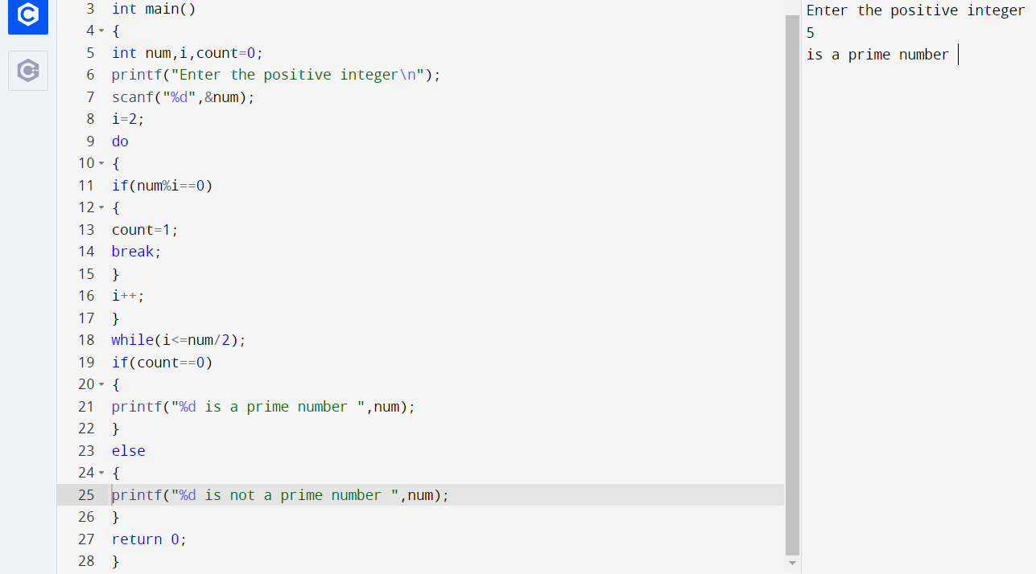

**Q12.** Display the number in reverse order. (Using do...while loop)

Ans – C Program & Output:

#include<stdio.h>

int main()

{

int n,a,r,s=0;

printf("Enter The Number:");

scanf("%d",&n);

a=n;

do

{

r=n%10;

s=s*10+r;

n=n/10;

}

while(n>0);

printf("\n The Reverse Number of %d is %d",a,s);

return 0;

}

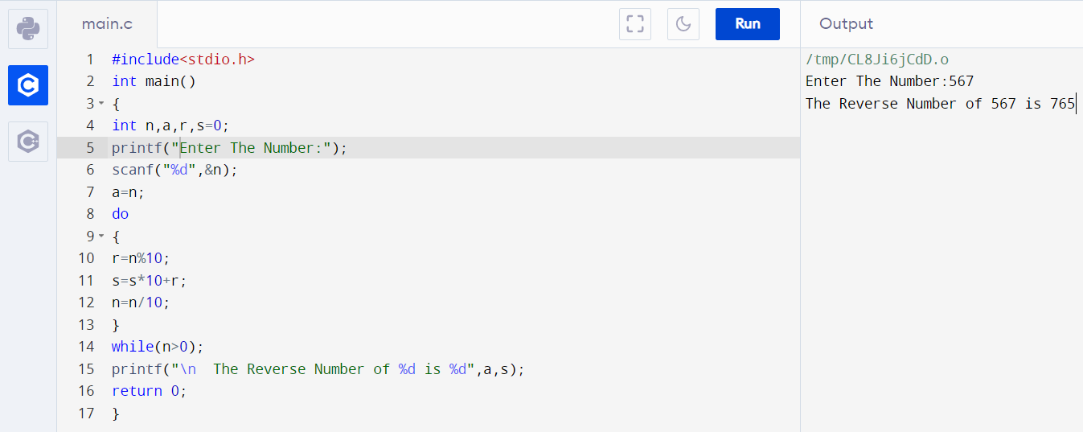

**Q13.** Display the sum of the series [ 9 + 99 + 999 + 9999 ...] (Using for loop)

Ans – C Program & Output:

#include <stdio.h>

int main()

{

int n,i,t=9;

int sum =0;

printf("Input the number or terms :");

scanf("%d",&n);

for (i=1;i<=n;i++)

{

sum +=t;

printf("%d ",t);

t=t*10+9;

}

printf("\nThe sum of the series = %d \n",sum);

return 0;

}

